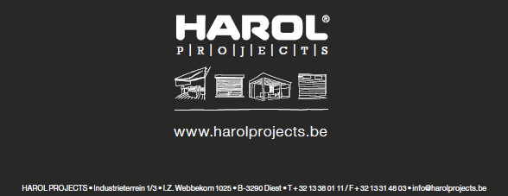
SPECIFICATIONS VZ080 veranda sunblind HAROL
1. GENERAL
-The fabric of the blind is protected and rolled up in a box which is closed by the extension pole when the screen is completely retracted. The box is fixed to the guide rails.
-The fabric is kept at a safe distance from the veranda roof by the position of the guide rails and a cable spring system that keeps the fabric under constant tension.
-The system is so designed as to enable any minor positioning tolerances in the roof sections to be easily absorbed. The entire system is made of non-corroding materials.
There are several assembly options, as standard, the VZ080 is fitted above the veranda. It can then be fixed onto the veranda brackets using supports. There are several brackets available for this.
- It is provided with a zip system that ensures the fabric remains properly tensioned at every height position of the extension pole, which prevents the fabric from pulling out of the guide rails. The sections of fabric are always finished with a zip on the left and right, of which the thicker side slides into a plastic zip profile. This is placed in a separable aluminium guide profile.
- Consisting of:
• A box with an easily removable, motor-controlled fabric roll.
• A polyester fabric with zip that is rolled up in the box.
• Separable guide rails to reach the zip guide easily.
• An extension pole with spring to keep the fabric tensioned.

2. ASSEMBLY METHODS
It can be assembled in various ways. The choice of assembly method has an effect on such things as the technical possibilities, drainage holes and so on.
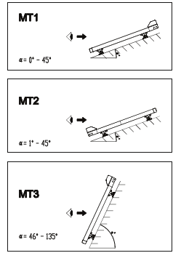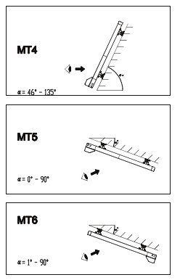
MT1 to MT4 − Outdoor assembly − Sunblind viewed along outside − Fabric hangs down the outside − Zip on window side − Drainage holes in extension pole and, as required, in box − Alu side of the fabric points to the sun for Soltis 86 and 92 − Grey film is on the window side (for blackout fabric)
MT5 – MT6 − Indoor assembly − Sunblind viewed along inside − Fabric hangs down the inside − Zip on window side − No drainage holes in extension pole and box. - Alu side of the fabric points to the floor for Soltis 86 and 92. - Grey film is on the window side for blackout fabric.
3. PROFILES
3.1. The separable guide rails − Material: extruded aluminium with powder-coating − Wall thickness: 1.5mm − Colour: choice from RAL colour range
- Two types:
• Lateral guides: installed on outer sides, with a rail slot on one side only.
• Coupling guides: installed in the middle, with a rail slot on either side.
The profiles have a hollow chamber into which the support pins of the side caps fit. - Aluminium end caps coated to match the frame.
3.2. The fabric roll consists of a circular extruded tube made of aluminium, with a groove for attaching the fabric, in order to roll up and roll down the fabric. Diameter: Ø67 x 1.8 mm.
3.3. Zip guide profile consists of extruded PVC clips.
Absorption of the zip profile on the fabric to keep the fabric tensioned with the aid of stainless steel springs.
3.4. The box is made of extruded aluminium with powder coating
- Thickness of wall: 2mm
− Dimension: 134mm x 118mm
- Colour: choice from RAL colour range
- Consists of two sections: • A removable chamfered upper section or cover. • A fixed lower section. - A fabric guide profile is attached to the fixed section, which guides the fabric out of the box. - A brush is secreted in the cover.
3.5. The extension pole is made of extruded aluminium with powder coating
- Thickness of wall: basic section 2 mm
- Locking profile 1.5 mm
- Colour: choice from RAL colour range
- Function: • The lower section: has a groove for attaching the fabric. • A locking profile: is clipped on to the lower section. • Runs along the grooves in the lateral guides via specially designed sliding blocks. - Optionally, a rubber or brush can be fitted to the front of the extension pole. In certain assembly situations, these can also be fitted to the underside of the extension pole, during installation.
4. SIDE CAPS
4.1. The side caps consist of high-pressure-cast aluminium with powder coating. - Colour: colour of frame - Dimensions: 134 x 118 mm. - There are 2 types of caps: side caps and coupling caps

4.2. The sliding blocks - Material: Plastic injection moulding - Colour: black. - Function: • Connection of extension pole and guide rails, fitted with a sliding surface that meshes into the running surface of the guide rail. These are screwed into the left and right of the end of the extension pole.

4.3. Guide rail covers − Material: high-pressure-cast aluminium with powder coating. - Colour: colour of frame - Function: • cover guide rail • turn-over wheel cord

4.4. The tensioning system - Material: the castors, axles, etc. are made of non-corroding materials. - Function: fabric and extension pole can be constantly kept under tension via a spring, castors and a cord of Ø2 mm. - This keeps the fabric at a certain distance from the glass roof when unrolled, so that there is a ventilation space between the sunblind and the glass roof (elimination of accumulated heat).

4.5. Mounting the guide rails
1. Without brackets • Please note: the fabric will always droop a little but must never touch the glass.
2. Standard aluminium bracket, with powder coating adapted to the colour of the frame.
- The brackets consist of two parts:
• The upper part: attached to the bottom of the lateral and central guides.
• The lower part, comes in two versions:
− Low bracket A − for veranda roof profiles with glass above and wooden pergola and veranda systems. - is screwed into the wood or into the groove at the top of the profiles into which the rubber seal is fixed.
- High bracket B - for veranda profiles with the glass beneath and screwed into the veranda roof profile with two bolts.
• The upper and lower parts can be adjusted laterally relative to each other. This allows small positioning deviations between guide profile and veranda profile to be absorbed.
• The extended supports are available in lengths of 120 mm, 200 mm, 300 mm or 400 mm.
• The maximum permitted distance between two attachment points of a guide rail is 1600 mm.
Option to pre-drill holes in the guide rails (along the bottom or in the side) If it is decided to pre-drill the guide rails, no supports will be provided. Holes of Ø5 mm will be provided, at max. 500 mm distance apart. The fitter is responsible for the screws.

4.6. Wall assembly: for installing against a wall. There are 3 standardised L-profiles for this that can be provided in any desired length. (Always to be used with flat supports A) • Available in the following sizes: Type L1 = 50x30x3 mm Type L2 = 100x50x3 mm Type L3 = 130x50x5 mm

4.7. The coupling components can be used to couple two lateral guides. There are two coupling components in aluminium: - The coupling plate, or alternatively, the coupling angle

5. MOTOR
Drive via tubular motors: 230 Volt (50Hz), fitted far left and/or far right as required
Standard:
• Fitted with automatic readjustment - this means the motor switches to a lower gear at approx. 10 cm before the box closes, so that the sunblind stops correctly and there is no need to make a readjustment for any stretching of the fabric. (SLT motor)
• Fitted far left and/or far right as required • 3 m electric cable. • Single-pole surface-mounted switch.
Optional:
• Electric cable 5 m or 10 m, without switch.
• Motor with automatic readjustment; screen will always close completely (Orea WT). - Without readjustment buttons; end points to be adjusted via cable, via an adjustment set. - Connectable in parallel (number determined by type of switch). - 3 m electric cable. - Single-pole surface-mounted switch.
• Motor with built-in RTS receiver (Orea RTS). − 5 m electric cable, - optional 10 m electric cable − with RTS wall transmitter, - optional without RTS wall transmitter
• Motor with built-in IO receiver (Sunea IO). − 5 m electric cable, - optional 10 m electric cable − with IO wall transmitter, - optional without IO wall transmitter
- RTS and IO motors are supplied with the options “back release” and “reduced closing force” activated

6. TECHNICAL OPTIONS
- Minimum width per element: 0.85 m - Maximum width per element: 3 m − Maximum drop: 3.5 m· - Maximum surface area per fabric: 10.5 m2
If the composite ordered width is less than 6 m, everything will be supplied in a single box part. If the width is greater than 6 m, two separate parts will be supplied, to be linked to each other on site.
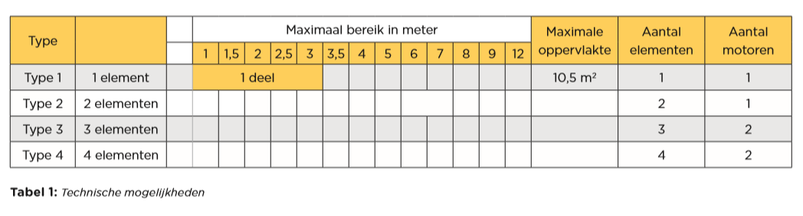
7. FABRICS
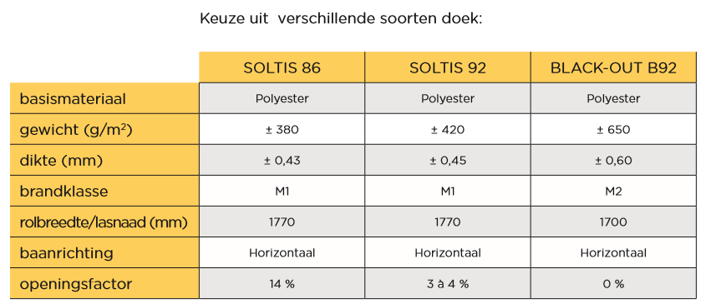
-Soltis 86 and Soltis 92 − Transparent and light-inhibiting fabrics. - Woven from polyester thread, stretched under great tension and secured with a plastisol layer. - Varnished on both sides -> excellent protection against UV radiation. - High tear strength without additional reinforcement. - Durable and dirt repellent. − Exceptional dimensional stability when used between -30°C and +70°C. − Sunblinds with a drop of -> 2670 mm are fitted with a horizontal weld seam! - With two-tone fabrics, the Alu side is always on the outside or on the garden side with assembly types 1-4; with assembly types 5-6 always towards the floor. - Minimum slope angle 8°, if there is a chance of light rain on the fabric.
- Blackout fabric B92 - Opaque and light-blocking fabric. - Woven from polyester thread, stretched under great tension and secured with a plastisol layer. - Supplied with a light-blocking PVC coating on one side (window side). - Wind can cause the bottom lath and fabric to lift up, and as a result it is not possible to guarantee that light is blocked 100%. - Sunblinds with a drop of -> 1700 mm are fitted with a horizontal weld seam! - Minimum slope angle 15°, if there is a chance of light rain on the fabric.
-Finish Zips are placed on the sides of each fabric, and with correctly fitted guide rails, the zips ensure that the fabric is tensioned in any height position of the extension pole, thanks to the tension between the zip and the guide rails.
For the blackout blinds, the zips are welded to the Soltis side of the fabric, not to the blackout foil side, in order to obtain better adhesion and less movement of the fabric. With the Soltis 86/92 blinds, the zips are always on the back of the fabric or, in other words, on the side of the window.
8. FRAME COLOUR
According to RAL colour range.
9. FASTENING MATERIALS
All fastening materials are of stainless steel and accessories are always included.

