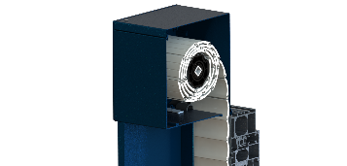
SPECIFICATION DESCRIPTION – Flush-mounted roller shutter VR1000
Harol or similar
The VR1000 flush-mounted roller shutter is first installed onto the window frame, before being fitted into the façade, along with the entire window structure.
The fact that the roller shutter is installed outside the thermal shell of the building makes it suitable for renovation and new-build projects involving passive and low-energy dwellings.

The box:

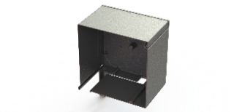
- The external frame of the box is built from 2 sections of extruded aluminium: the L-shaped front panel and the hinged inspection cover inside this.
- The back of the box is a rolled aluminium plate and the sides are sealed using aluminium side consoles.
- The VR1000 is only available in model ‘C’ and in 4 different sizes: 150-165-180 and 205. The aluminium console has a pin which the guide rail fits into.

The guide rails:
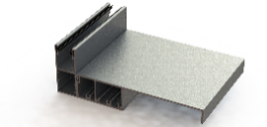
The full-width guide rails comprise a base guide (B) equipped with EPDM seals (A). This base guide is secured against the window. The clip profile (C) is then screwed onto it, after which the cover (D) can be clipped onto the clip profile.

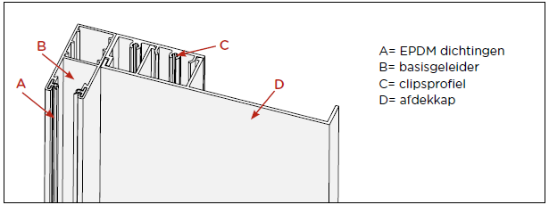

Material: extruded aluminium.
Colour: supplied in the same colour as the box as standard.
Types: various types with different dimensions available, depending on the situation.
Installation: blind attachment

The shutter curtain:

Slat types
PVC37, MIDI, ALU35, ALU37 ALU42, ALU42S & ALU42TH
−PVC37 and MIDI: double-walled plastic.
−ALU35, ALU37 ALU42, ALU42S and ALU42TH: double-walled, foam-insulated aluminium.

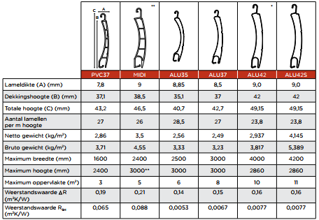

Slat colour table

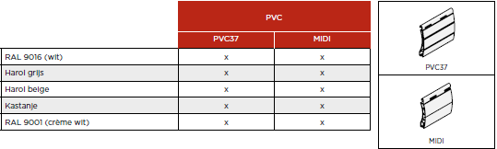
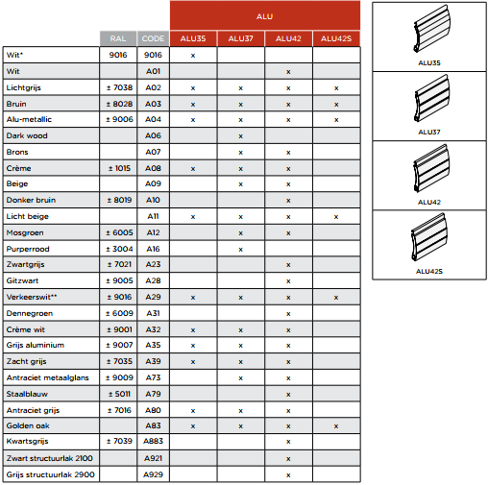

- Both the PVC and the ALU shutter curtains can be fitted with light and ventilation slots. These are slots punched from the lip of the slats, which are released when the curtain is partially lifted. They can allow air to circulate when the shutter curtain is almost closed.
- Options: without - 1/3 - 1/2 - 2/3 - 1/1 (7 fixed slats above, the rest with slots)
- If the roller shutter must provide blackout shade, it is best to avoid light and ventilation slots.
- The shutter curtains will be finished with an extruded ALU bottom lath with a rubber seal.

Controls:
The VR1000 is always electrically operated. The operating side can be either on the left or the right. As with all roller shutters, this is seen from inside-out. The motor is attached blind to the support plate in the console by means of a motor bracket, so that the screws are not visible from the outside.

The controls comprise a built-in, asynchronous tubular motor. This motor must be connected to the existing mains network.
Available motor types:

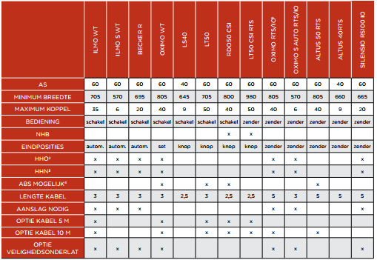

- LT: wired motor with control buttons for setting the upper and lower positions
- Ilmo: wired motor with fully automated settings
+ intelligent obstacle detection in up and down movement
- RTS & IO: radio-controlled motor with choice of fully automated or manual settings.
+ intelligent obstacle detection in up and down movement
- CSI: wired motor NHB with control buttons for setting the upper and lower positions

Costs falling under electricity: cabling for the control and power supply of the roller shutters

Roll-up shaft:

- The roll-up shaft is manufactured from galvanised steel 8K profile.
- Diameter 40 mm or 60 mm depending on controls and dimensions of the flush-mounted roller shutter.
- The roller shutter is secured to the shaft by means of flocked suspension springs (3 items/m) or suspension links. There is a choice between these options, depending on controls.

